

Deer Park Middle Magnet School Presents

2013 Spring Fashion & Talent Show

**Part 1: Talent Show**

**Performer Song Talent Grade**

1. Troi “Someone Like You” by Adele vocal 6

2. Cjett “New Beat Fall 2001” by Jabbawockeez dance 6

3. Synaia “WNBA” written by Synaia vocal 7

4. Mide “Soldier Girl” by Cymphonique dance 7

Teni

5. Hallemat “Pretty Girl Rock” by Keri Hilson vocal 6

6. Ariana “Put Your Records On” by Corinne Bailey Rae vocal 8

7. Raniya “Stay” by Rihanna vocal 7

8. Michael “Johnny B. Good” by Chuck Berry vocal 7

9. Tylah “I Have Nothing” by Whitney Houston vocal 8

10. Teri “Make a Move” by Royal Tailor dance 8

11. Majenta “No Church in the Wild” written by Majenta vocal 8

12. Mercedes “If I Ain’t Got You” by Alicia Keys vocal 7

13. Niya “Get Crazy” by Nicki Minaj ft. Lil Wayne dance 6

14. Breonna “Weak” by SWV vocal 7

**15-Minute Intermission**

Cupcakes, Chips, Drinks will be on sale in the Lobby courtesy of the DPMMS PTA.

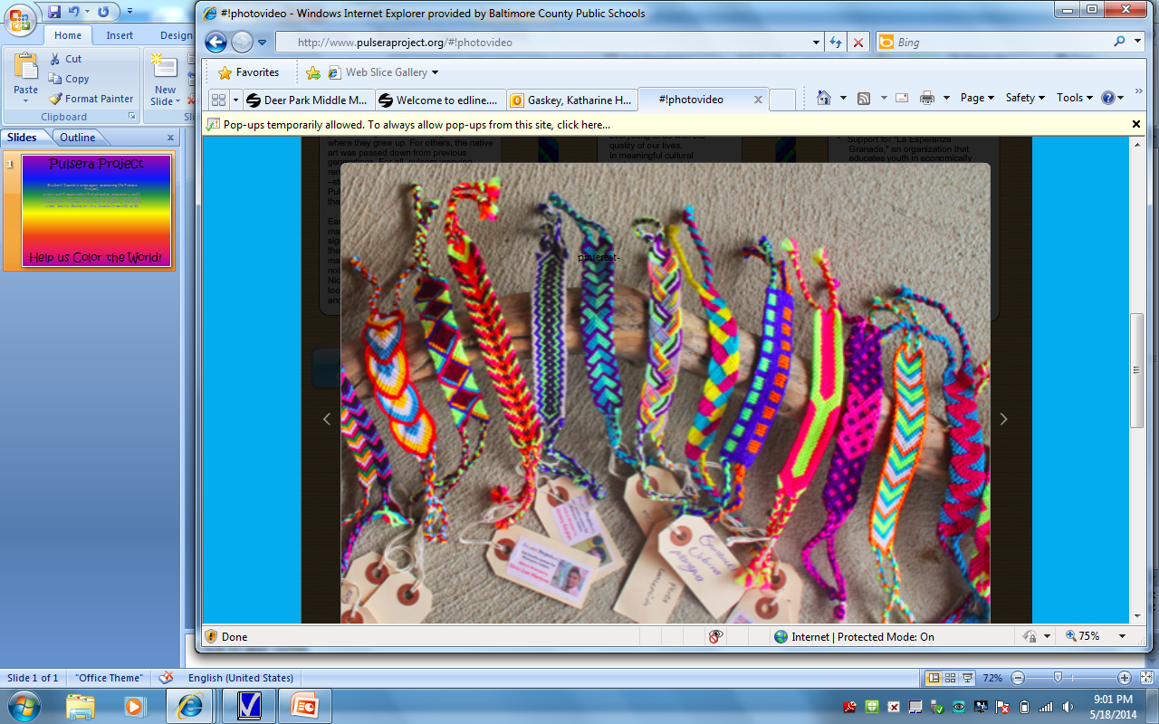

“Pulseras” will also be on sale in the Lobby courtesy of DPMMS Student Council, who is participating in the Pulsera Project, a non-profit organization that educates and empowers youth from Nicaragua. We will be selling hand-made bracelets, or “Pulseras” in Spanish, for $5 each. All proceeds will be sent directly to Nicaragua.

**Part 2: Spring Fashion Show**

Scene I – “Pajama Jam” **Featuring: Kayla; Warren; Shon; Teauna; Keshon; Fola; Mona**

Scene II – “Let’s Get Active” **Featuring: Kaprease; Treasure; Jada; Josean (J.J.); Zoey; Imonni**

Scene III – “Dress For Success” **Featuring: Kayla; Shamyah; Kindel; Nyzhe; Lelyan; Dominique**

Scene IV – “Let’s Party” **Featuring: Kalynn; Tyanna; Kaiya; Jayda; Shivone; Kiana; Brianna**

Scene V – “Rip the Runway” **Featuring: Kalynn; Tyanna; Kaiya; Jayda; Shivone; Lelyan; Imonni**

Scene VI – “Finale” **Featuring: Warren; Shon; Kalynn; Tyanna; Treasure; Kaiya; Jayda; Shivone; Kiana; Keshon; Brianna; Josean (J.J.); Lelyan; Imonni**

The Committee

Mrs. Delores. . . . . . . . . . . . . . . . . . . . . . . . . . . . . . . . . . . . . . . . . . . . . . . . . . . . . DPMMS Principal

Mr. Aubrey. . . . . . . . . . . . . . . . . . . . . . . . . . . . . . . . . . . . . . . . . . . . . . .DPMMS Assistant Principal

Ms. Cynthia. . . . . . . . . . . . . . . . . . . . . . . . . . . . . . . . . . . . . . . . . . . . . . . . . DPMMS PTA President

Katie Gaskey. . . . . . . . . . . . . . . . . . . . . . . . . . . . . . . . . . . . . . . . . . . . . . . .Student Council Advisor

Jennifer. . . . . . . . . . . . . . . . . . . . . . . . . . . . . . . . . . . . . . . . . . . . . . . . . . . . . . . . . PBIS Coordinator

Ramona. . . . . . . . . . . . . . . . . . . . . . . . . . . . . . . . . . . . . . . . . . . . . . . . . . . . .Kids4Kids Coordinator

The Crew

Brianna. . . . . . . . . . . . . . . . . . . . . . . . . . . . . . . . . . . . . . . . . . . . . . . . . . . . . . . Production Assistant

Mr. Lawerence. . . . . . . . . . . . . . . . . . . . . . . . . . . . . . . . . . . . . . . . . . . . . . . . . Lighting Coordinator

Joshua. . . . . . . . . . . . . . . . . . . . . . . . . . . . . . . . . . . . . . . . . . . . . . . . . . . . . . . . . . Lighting Assistant

Mr. Steven . . . . . . . . . . . . . . . . . . . . . . . . . . . . . . . . . . . . . . . . . . . . . . . . . . . . . .Music Coordinator

Justyn. . . . . . . . . . . . . . . . . . . . . . . . . . . . . . . . . . . . . . . . . . . . . . . . . . . . . . . . . . . . . . . Photography

Tonight’s Show was a collaborative production of the Deer Park Middle Magnet School and DPMMS PTA Family & Community Involvement Committee’s Kids4Kids Service-Learning Program.

Under the direction of Event Coordinators Ms. Ramona Basilio (PTA), Ms Gaskey (Student Council Advisor), and Mrs. Langdon (PBIS Coordinator), the aim of tonight’s program was to bring students, family, teachers, and the community together to celebrate Deer Park students’ extraordinary talent, service, and leadership abilities. This was a multimedia showcase of our students’ work, both on stage and behind the scenes.

Tonight’s proceeds support the DPMMS Student Council, Kids4Kids Service Learning, and PTA/DPMMS initiatives.

**Thank you for joining us!**

** Please note that for the purpose of this portfolio last names have been omitted from this program to protect the anonymity of the students and faculty at my school.